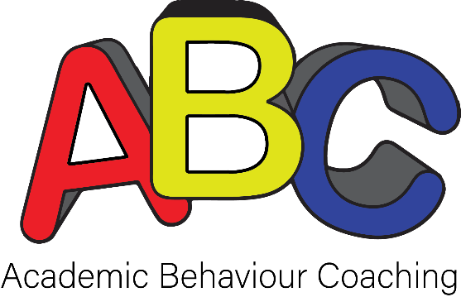

Skill Mastery Tracker
Student Name: Coach’s Name:

Skill Name (no more than 2-3 active skills at one time) | Instructed On: | Shared Application(s) 2-3 dates: | Independent Application(s) 2-3 dates: | Re-introduced Skill if needed (start new row): | Skill Mastery: | Short-term Retention Check (1-3 weeks from mastery date): | Long-term Retention Check (1-2 months from mastery date):
Ex: Due date tracking in Agenda | Oct 13 | Oct 15  Oct 20  Oct 22 | Oct 27  Oct 29  Nov 3 | not needed | Nov 3 | Dec 4 | Dec 28

